GRANARD MUNICIPAL DISTRICT

Corporate Affairs,
Aras an Chontae,
LONGFOIRT.
Please note meeting venue-
Council Chamber, Aras an Chontae.
12th October 2017.

To: Each Member of the Granard Municipal District.

A Chomhairleoir,

You are requested to attend a Meeting of the Granard Municipal District Committee on Tuesday, 24th October 2017 at 3.30 p.m. in the Council Chamber, Aras an Chontae, Longford to transact business as set out on the agenda hereunder.

Mise le meas,
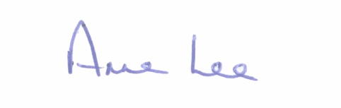

________________
Anne Lee,
Meetings Administrator.

1. Consideration of General Municipal Allocation 2018 for the Granard Municipal District.

:::::::::::::::::::::::::::::::

